High-Level Document (HLD)

Heart Disease Diagnostic Analysis

## Revision Number: 1.0 Last Date of Revision**:**

**Murala Divyasree**

# Document Version Control

|  |  |  |  |
| --- | --- | --- | --- |
| Date Issued | Version | Description | Author |
|  | **1.0** | First Version Complete HLD | Murala Divyasree |
|  |  |  |  |
|  |  |  |  |
|  |  |  |  |
|  |  |  |  |
|  |  |  |  |

## Contents

￼

**Abstract**

Heart disease is a term covering any disorder of the heart. Heart diseases have become a major concern to deal with as studies show that the number of deaths due to heart diseases have increased significantly over the past few decades in India it has become the leading cause of death in India. A study shows that from 1990 to 2016 the death rate due to heart diseases have increased around 34% from 155.7 to 209.1 deaths per 1 lakh population in India. Thus, preventing heart diseases has become more than necessary. Good data-driven systems for predicting heart diseases can improve the entire research and prevention process, making sure that more people can live healthy lives.

# 1 Introduction

1. ​

#### Why this High-Level Design Document?

The purpose of this High-Level Design (HLD) Document is to add the necessary detail to the current project description to represent a suitable model for coding. This document also Intended to help detect contradiction prior to coding, and can be used as a reference manual for how the modules interact at a high level.

The HLD will:

Present all of the design aspects and define them in detail Describe the user interface being implemented

Describe the hardware and software interfaces Describe the performance requirement

Include design features and the architecture of the project List and describe the non-functional attributes like:

* Security
* Reliability
* Maintainability
* Portability
* Reusability
* Application compatibility
* Resource utilization
* Serviceability

.1.Scope

The HLD documentation presents present the structure of the system, such as the database architecture, application architecture (layers), application flow (Navigation), and technology architecture. The HLD uses non-technical to mildly-technical terms which should be understandable to the administrators of the system.

# Generation Description

#### Product Perspective and problem Statement

Top 500 Companies Valuation and turnover is an important indicator of the performance of Indian economy which is world’s sixth largest economy in terms of GDP. These 500 companies’ performance also affect the performance of the Indian Economy because the companies range in various sector such as IT, Pharma, Banking, Real Estate, Entertainment and FMCG.

The objective of the project is to perform data visualization techniques to understand the insight of the data. This project aims apply various Business Intelligence tools such as Power BI and Tableau to get an visual understanding of the data.

1. ​

#### Tools used

Business Intelligence tools and libraries works such as NumPy, Pandas, Excel, Python, Power BI and Tableau are used to build the whole framework.







# Design Details

1. ​

#### Functional Architecture

Business

Data Analytics Intelligence

Structured

Datasets

Business

Analytics

Optimization Tools

Combine Data Analytics with KPI’s

Machine Learning Algos

Dynamic Pricing Algos

Data Sources

Step 1 :

Step 4 : Gather/Store/ Research Retrieve

Business Data

Companies Data Sources

Market Cap Data Sources

Sales Data Sources

Other Data Sources (Sebi and Market)

**Figure 1:**

Step 2:

Advanced Automate the Profiles

Analytics

**Functional**

Step 3 : Advanced Search

Algorithm

**Architecture of**

**Business Intelligence**

**How Power BI Really Works**

**Information**

**4**

Parallel Algorithm Execution

Combine Business analytics with specific Business Event

Cloud-based Infrastructure

**Integration**

**Memory**

**Insight Creation**

**Presentation**

**Organizational**

Visualization Tools

Statistics

Customer Segmentation

Clustering Algorithm

|  |  |  |  |
| --- | --- | --- | --- |
| **Business Analytic Tool** | **OLAP Tools**  **Visualization Tools** | **Text mining tools**  **Web mining tools** | **Data Warehouse**  **ERP** |
| **Data Mining**  **Real-time Decision** | **Digital Dashboards** | **Environmental Scanning** | **Knowledge Repository** |
|  | **Score Card** | **RFID** | **CMS** |
|  |  |  | **DMS** |

### Optimize and materialize your calculations

Perform calculations in the database Reduce the number of nested calculations.

Reduce the granularity of LOD or table calculations in the view. The more granular the calculation, the longer it takes.

* + LODs - Look at the number of unique dimension members in the

calculation.

* Table Calculations - the more marks in the view, the longer it will take to

calculate.

Where possible, use MIN or MAX instead of AVG. AVG requires more processing than MIN or MAX. Often rows will be duplicated and display the same result with MIN, MAX, or AVG.

Make groups with calculations. Like include filters, calculated groups load only named members of the domain, whereas Tableau’s group function loads the entire domain.

Use Booleans or numeric calculations instead of string calculations. Computers can process integers and Booleans (t/f) much faster than strings.

Boolean>Int>Float>Date>DateTime>String.

# KPIs

Dashboard will be implemented to display and indicate certain KPIs and relevant indicators for the

Cause.



As and when, the system starts to capture the historic/periodic data for a user, the dashboards will be included to display chart over time with progress on various indicator or factors.

* 1. ​

#### KPIs (Key Performance Indicators)

Key indicators displaying a summary of the Housing Price and its relationship with different metrics

1. Population Count by Gender
2. Heart disease by Thalach Type
3. Heart disease by chest pain type
4. Chest Pain Based on Age Cat.
5. ST depression vs Age 6.Cholestrol vs Sex name

# 1. Deployment

Prioritizing data and analytics couldn’t come at a better time. Your company, no matter what size, is already collecting data and most likely analysing just a portion of it to solve business problems, gain competitive advantages, and drive enterprise transformation. With the explosive growth of enterprise data, database technologies, and the high demand for analytical skills, today’s most effective IT organizations have shifted their focus to enabling self-service by deploying and operating Tableau at scale, as well as organizing, orchestrating, and unifying disparate sources of data for business users and experts alike to author and consume content.

Tableau prioritizes choice in flexibility to fit, rather than dictate, your enterprise architecture. Tableau Server and Tableau Online leverage your existing technology investments and integrate into your IT infrastructure to provide a self-service, modern analytics platform for your users. With on-premises, cloud, and hosted options, there is a version of Tableau to

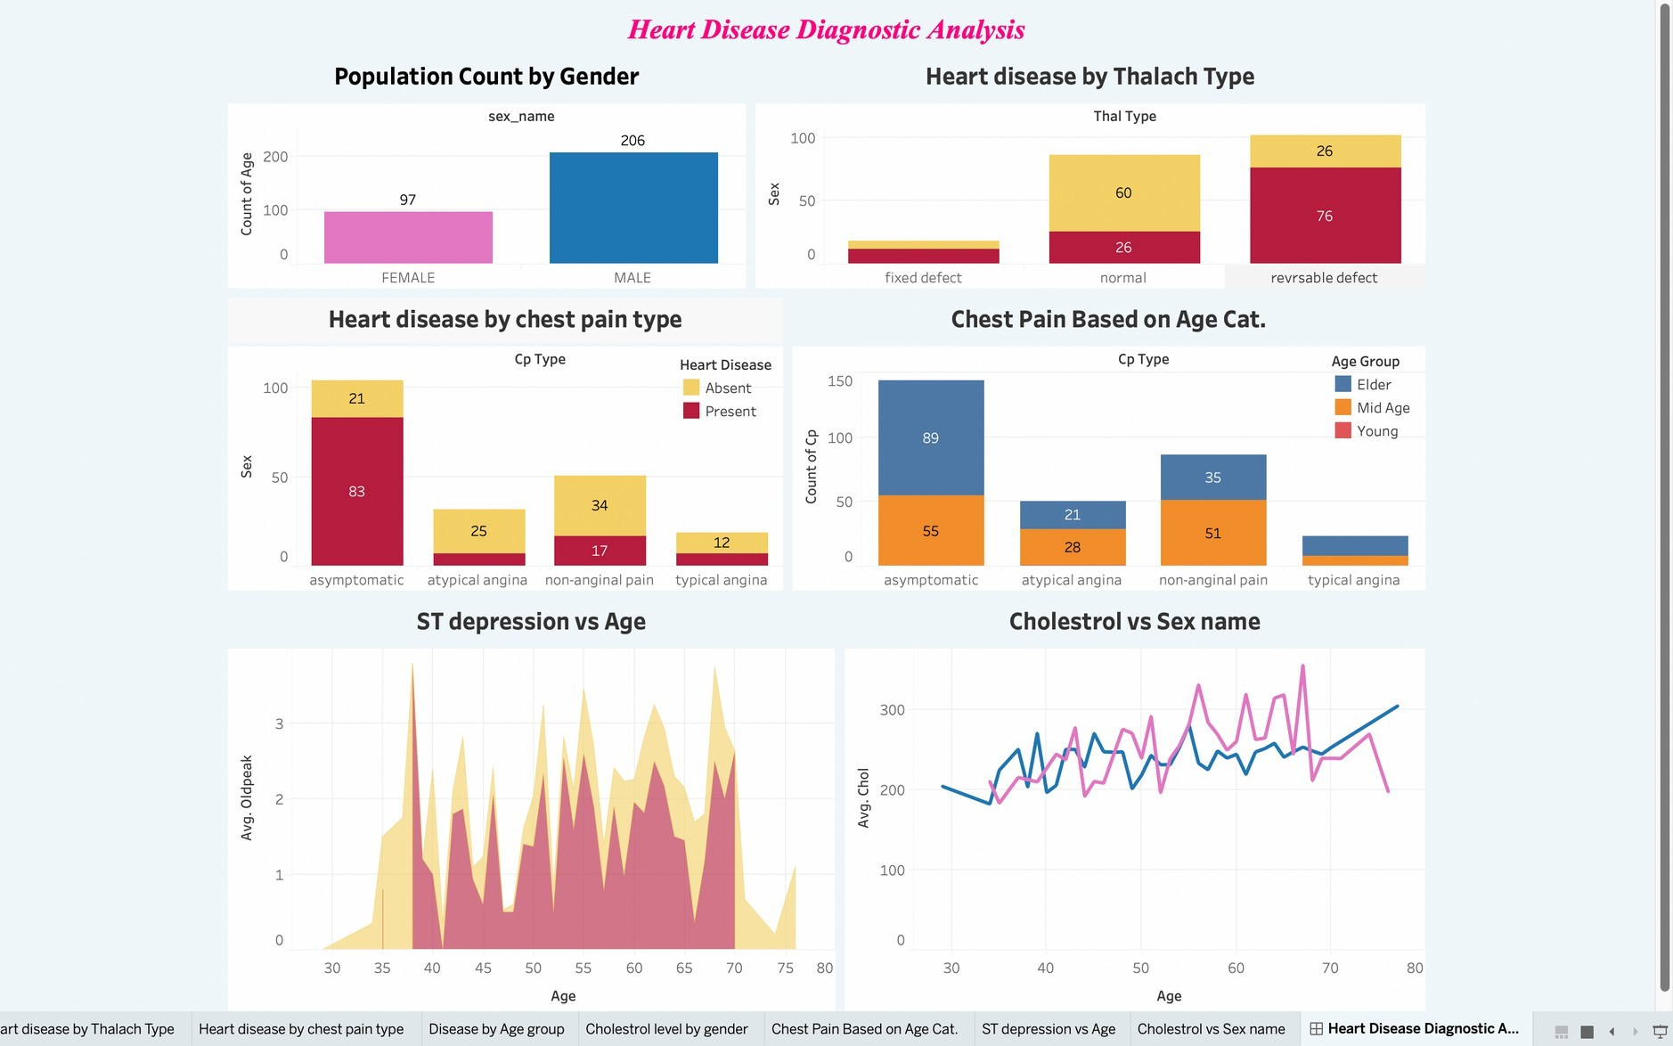match your requirements. Below is a comparison of the three types:

No guest account acce

Depending on your organizational roles and responsibilities, Tableau Server should be installed by a systems administrator and the designated Tableau Server Administrator in coordination with the appropriate IT roles. For Tableau Online, you will integrate with your existing technology and configure the site settings. The Data & Analytics Survey, completed by business teams, identifies and prioritizes data use cases, audience size, and users. You will use the information collected in both surveys to plan your deployment strategy, including sizing, installation, and configuration of your Tableau Server or integration and configuration of Tableau Online. In addition to installing Tableau Server or configuring Tableau Online, administrators will also need to plan for the client software installation of Tableau Prep Builder, Tableau Desktop, Tableau Mobile, and Tableau Bridge for Tableau Online where applicable.